User guide nrs_linreg_fsGUI

Purpose
Calculate feature space (2D scatter plot) and regression parameters in the feature space of two images; there are two distinct options:
- One time calculation on two images, then plot the feature space and regression line in a plot window
- Batch process a dual time series of images:
  - Calculate a feature space between images of each time series at the same moment
  - Calculate the linear regression parameters slope, intercept and also the coefficient of explanation R²

Installation
Copy the nrs_linreg_fsgui.sav file in the save_add folder of ENVI, and start ENVI. For detailed instructions see also ENVI .sav files: Installation and configuration

Running
Start ENVI. In the menu:
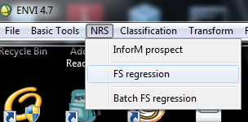
Select the appropriate user interface:
- The NRS | FS Regression for the plot version, or type nrs_linreg_fsGUI on the command line. You will see something like:
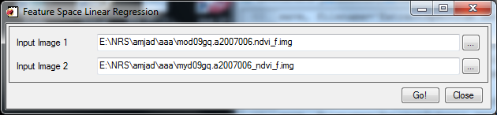
- The NRS | Batch FS Regression for the batch option or type nrs_linreg_fs_batGUI on the command line. You will see something similar to:
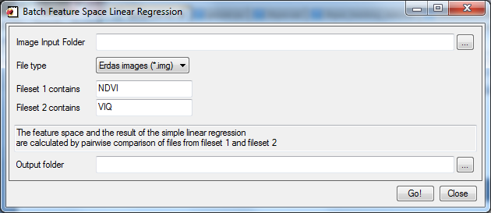
Where:
- Image Input Folder: the folder where both time series are located. Assumption: both time series contain exactly the same amount of images, and have the same name (except for the file name part indicating one or the other of the time series: see also point 3).
- File type: Filter for the type of the images; possible selections are ERDAS Imagine, HDF files and no file type filter (all files).
- File set 1 contains and file set 2 contains: text indicates which time series the file belongs to
- Output folder: The folder that will contain the feature space files (in ENVI format) of all image pairs, as well as a text table (comma delimited) with the regression parameters for each image pair. It is advised to select a different folder than the input (default = <input_folder>\out).

Plotting (PLlot version)
After file selection in the UI, click the Go! button to start the calculation and display the plot. The plot displays in the top right corner of the screen and looks similar to this:
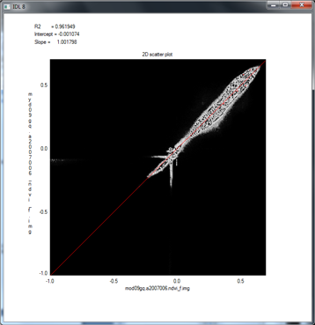
The plot window displays the 2D scattering (B/W) and the regression line (red). The X-axis is the first file, the Y-axis the second file. The regression parameters are displayed in the top left part of the plot.

File selection (Batch version)
File selection is based on a type filter (the File type combo box) and the fileset 1 contains and fileset 2 contains fields. For example we have these files:
NDVI_Terra_A2010097.h18v07.img
VIQ_Terra_A2010097.h18v07.img
NDVI_Terra_A2010081.h18v07.img
VIQ_Terra_A2010081.h18v07.img
The filename are almost identical (same platform, same date, etc) except for the NDVI and VIQ parts. The file filter selects all files (they all match *.img).
The NDVI is used to select the first time series and the VIQ is used to select the second. Then the time series filenames are sorted:
List 1 | List 2
NDVI_Terra_A2010081.h18v07.img | VIQ_Terra_A2010081.h18v07.img
NDVI_Terra_A2010097.h18v07.img | VIQ_Terra_A2010097.h18v07.img
Notice that this only correctly organizes the files pair wise when one date occurs in both lists. Important: No care is taken to detect mismatches in the pair wise names!

Calculation (Batch version)
The image pairs are taken and a feature space is calculated, with values from the images from list 1 on the X-axis and image 2 on the Y-axis. This feature space is stored in a file with name: <input name of list 1>_fs (no extension) in the output folder. For the example files above you will get:
NDVI_Terra_A2010081.h18v07_fs
NDVI_Terra_A2010081.h18v07_fs.hdr
NDVI_Terra_A2010097.h18v07_fs
NDVI_Terra_A2010097.h18v07_fs.hdr
For each file the software also creates a header file (.HDR) containing metadata.
The regression parameters are collected for all feature space and stored in a single table (comma delimited). It contains 6 fields:
- Filename from list 1
- Filename from list 2
- Filename of their feature space
- Slope
- Intercept
- R2

Example (for brevity only relative file paths have been used):
file1,file2,feature_space,slope,intercept,R2
NDVI_Terra_A2010081.h18v07.img, VIQ_Terra_A2010081.h18v07.img, out\NDVI_Terra_A2010081.h18v07_fs.,1.512346,0.110034,1.512341
NDVI_Terra_A2010097.h18v07.img, VIQ_Terra_A2010097.h18v07.img, out\NDVI_Terra_A2010097.h18v07_fs.,1.419296,0.080461,1.007953

